V—129:(CheckPoint Files) and V—130:(CheckPoint CatchUp):

These two videos are about previous source code.

V—131:(Reminder on -it Flag):

This is a reminder to use the -it flag when you test the React container after building from the Dockerfile in the next lecture:

docker run **-it** CONTAINER_ID

V—132:(Dockerizing a React App):

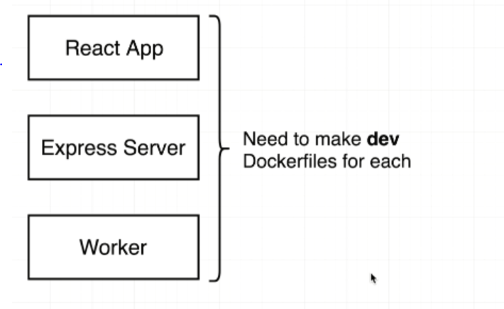

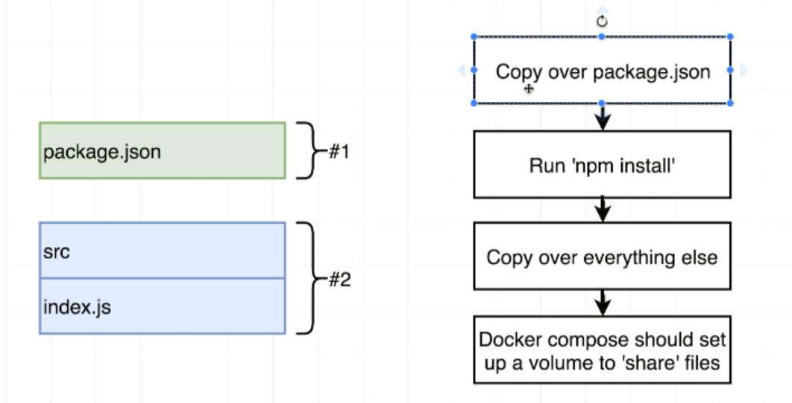

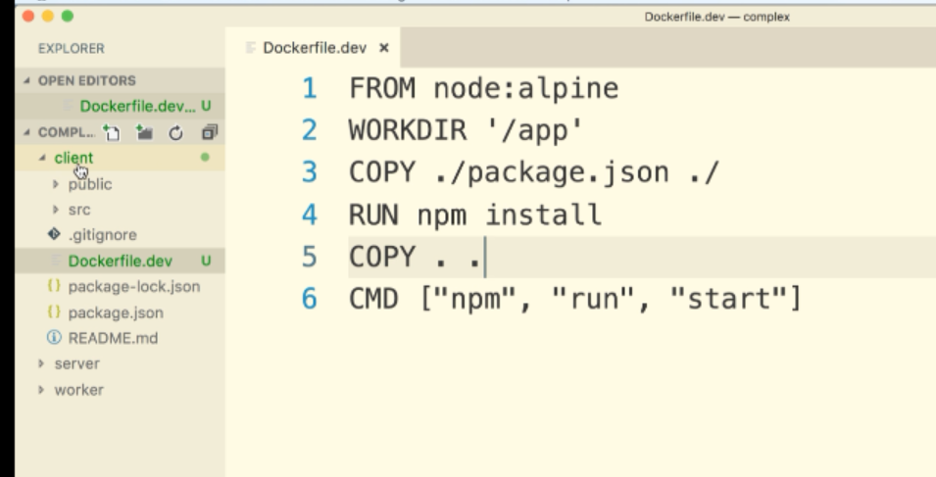

Building Client:::

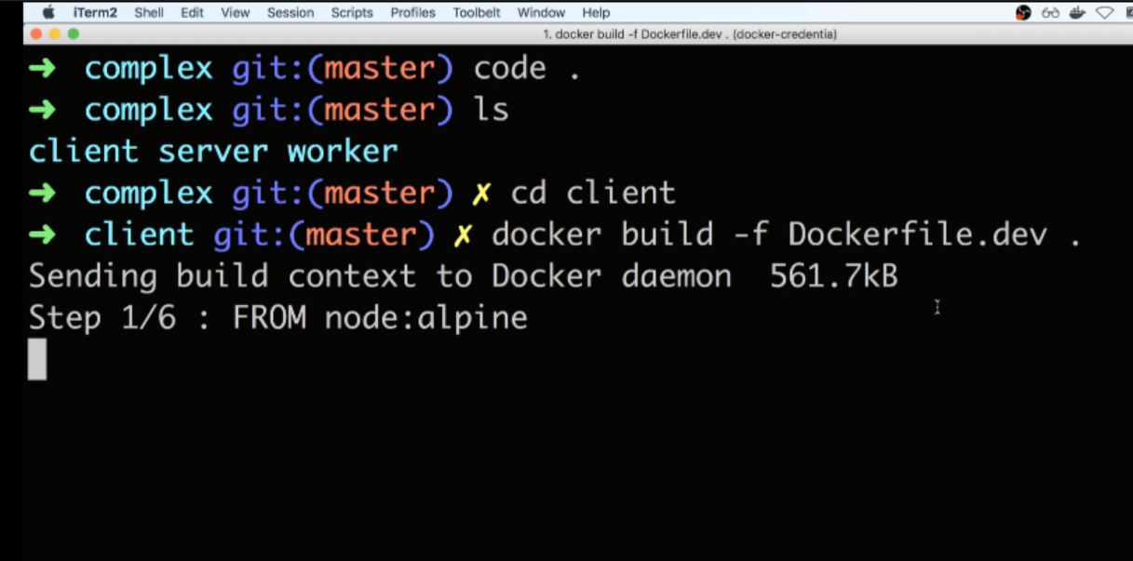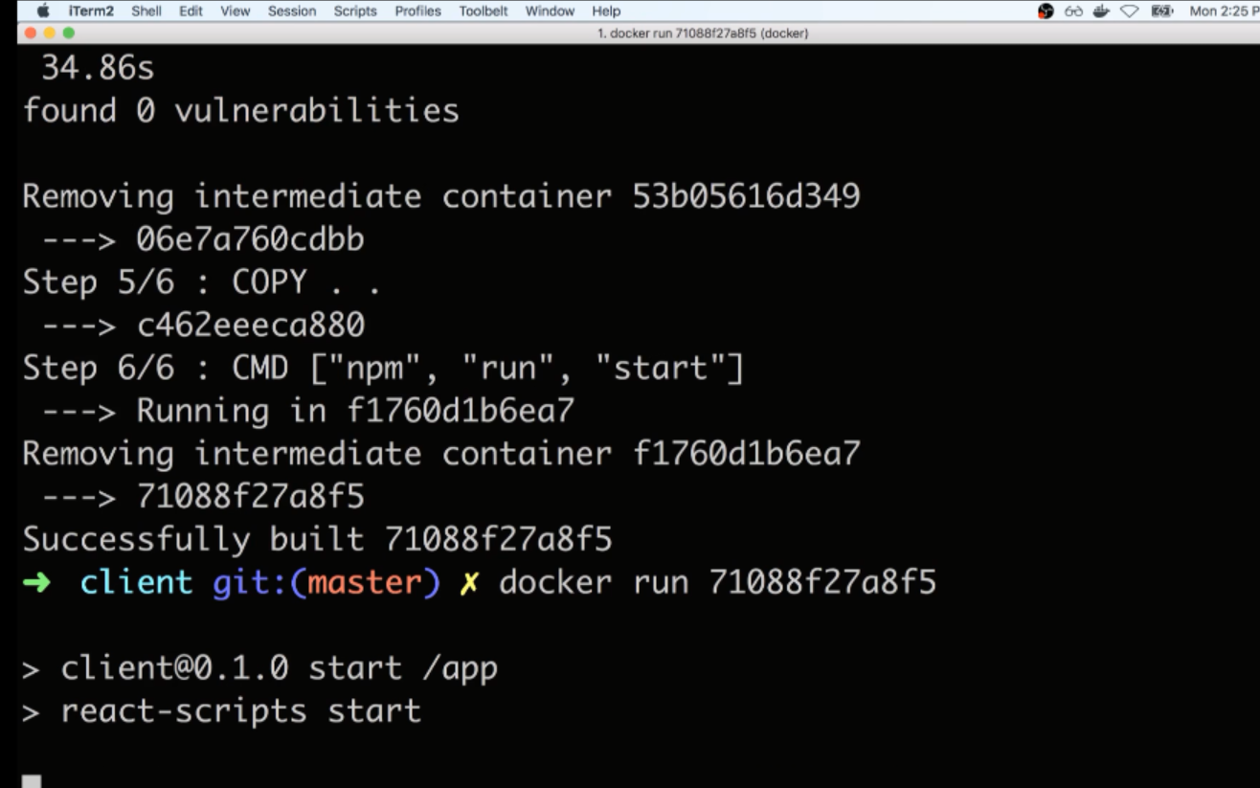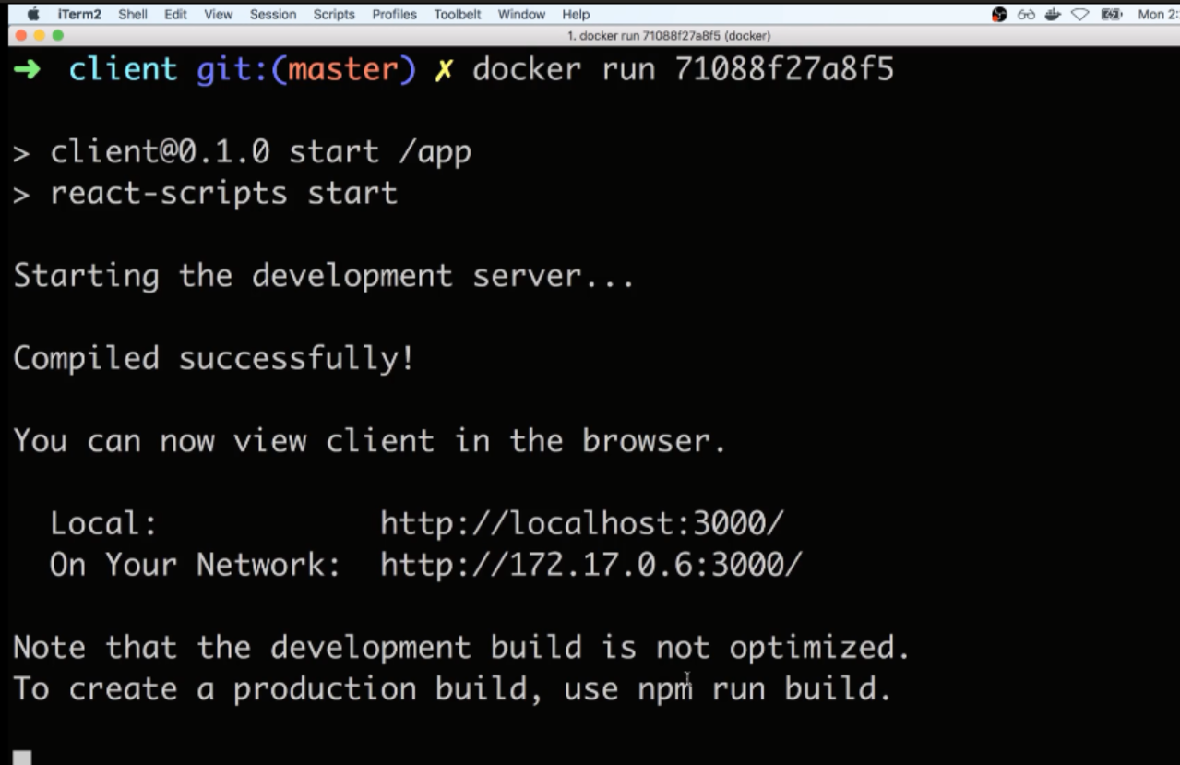

V—133:(Important Node Image Version Update):

10-24-2020

In the next lecture, we will be creating a Dockerfile.dev for the server container. The Node v15 image was just released a few days ago and is breaking the code in our server/index.js.

To work around this, we need to change the version of Node this container will use:

FROM node:alpine

to this:

FROM node:14.14.0-alpine

V—134:(Dockerizing Generic Node app):

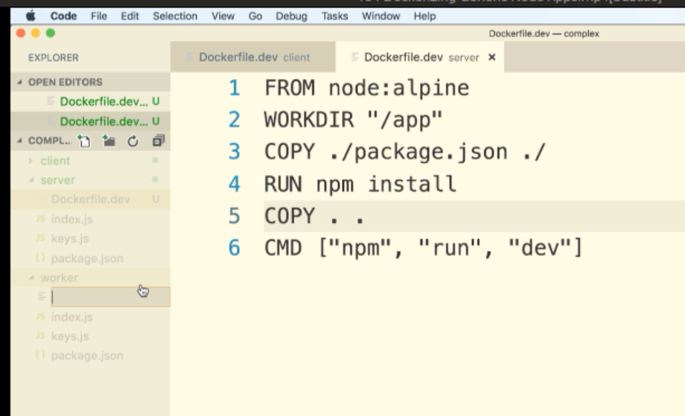

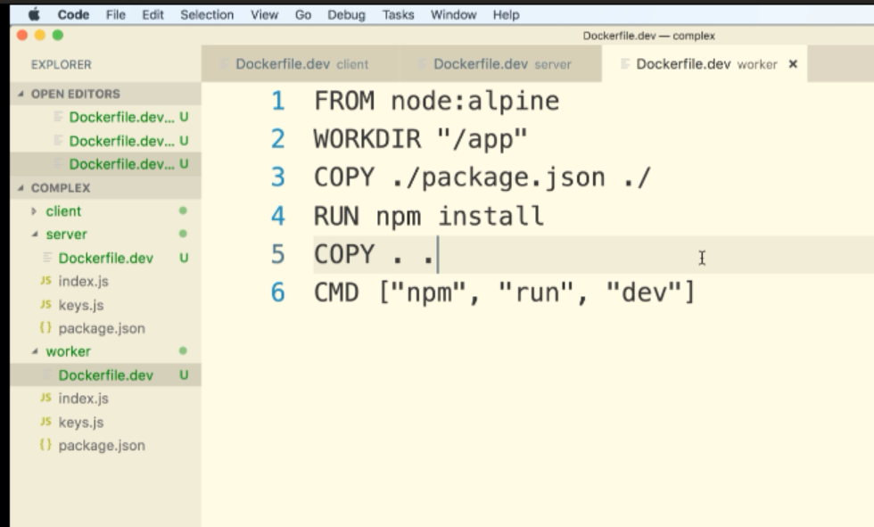

Building Server :::

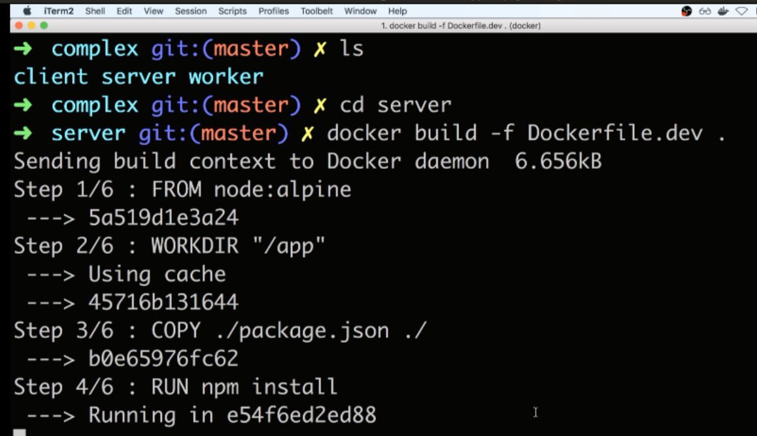

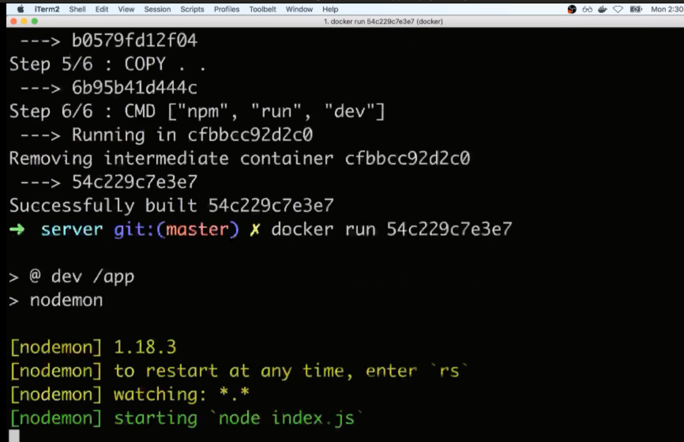

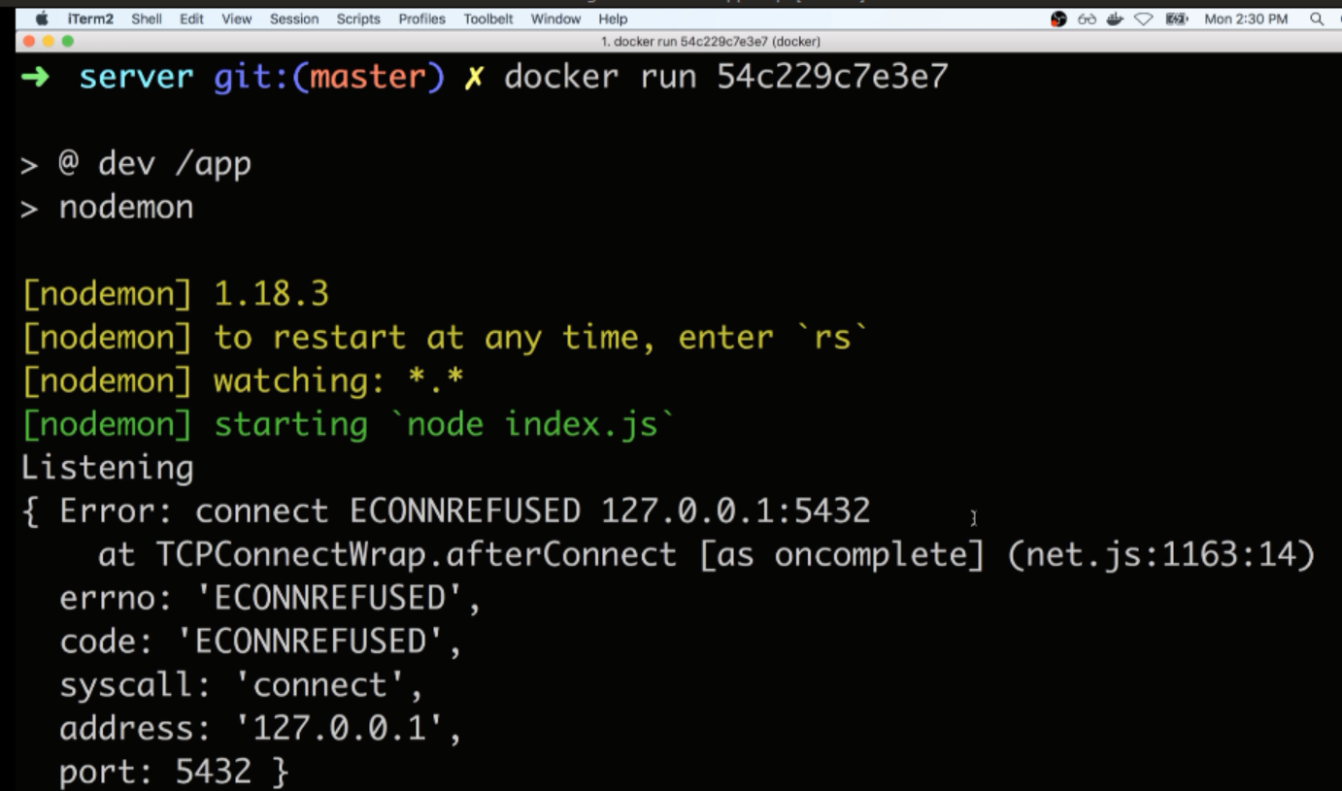

Error because we are not running a Reddis server or Postgres server

Building worker:::

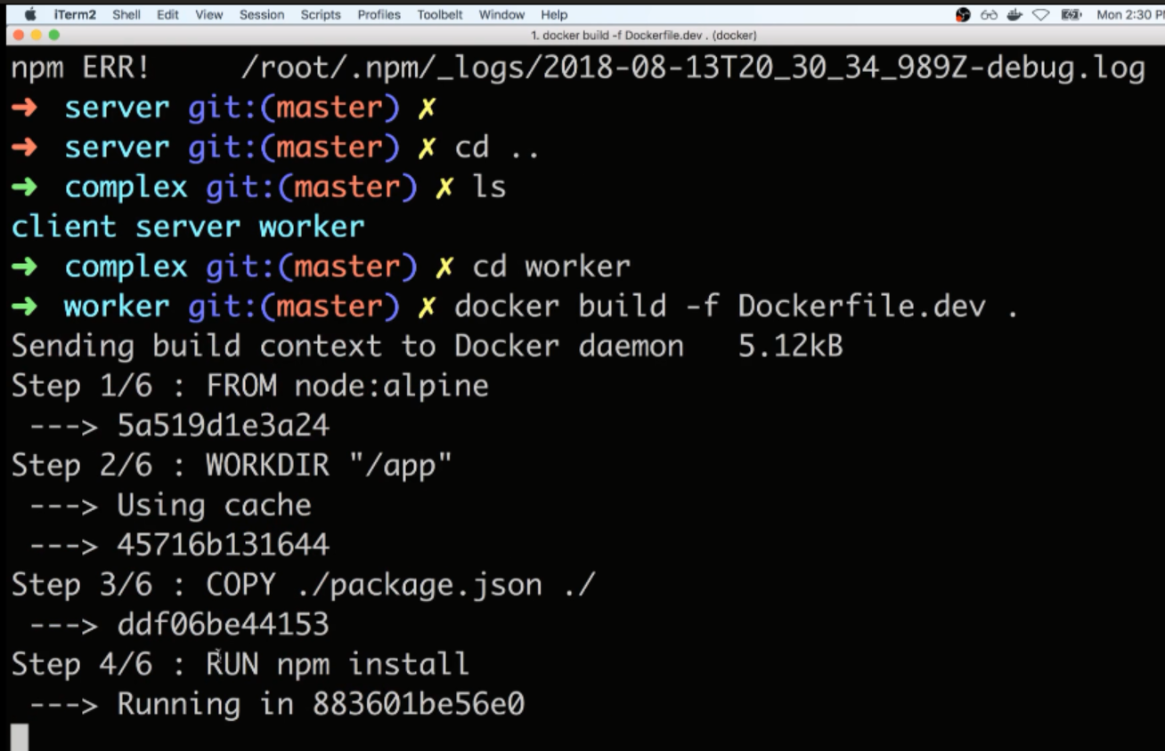

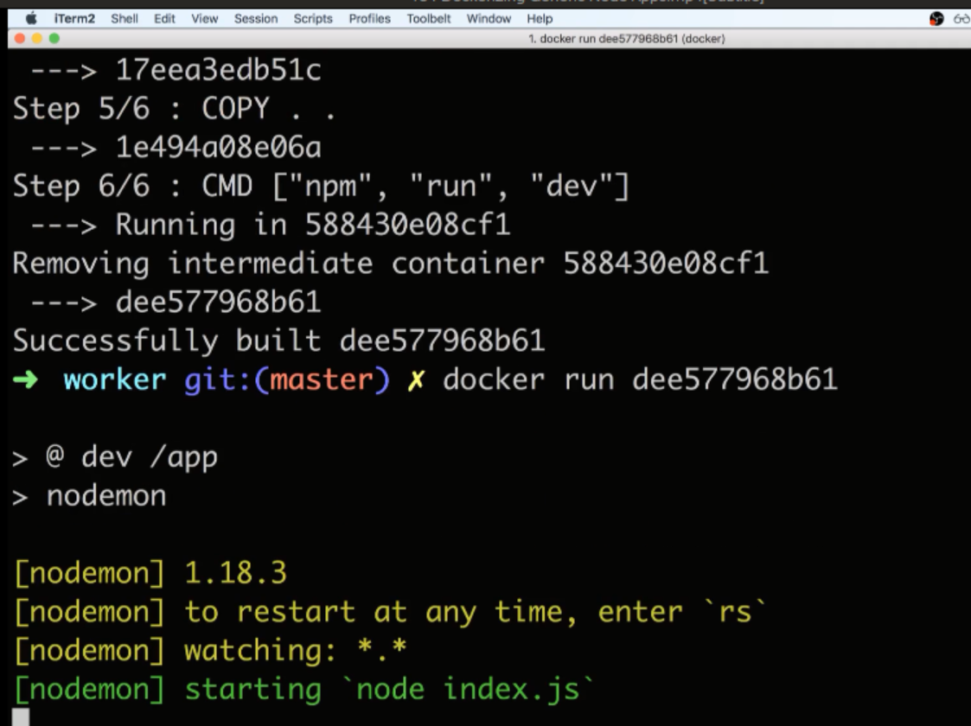

135:(Adding Postgres as a Service):

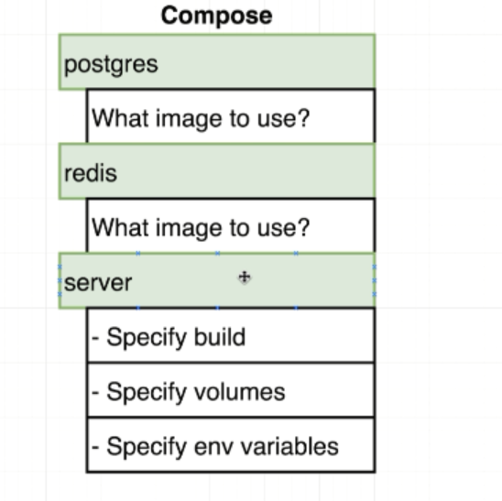

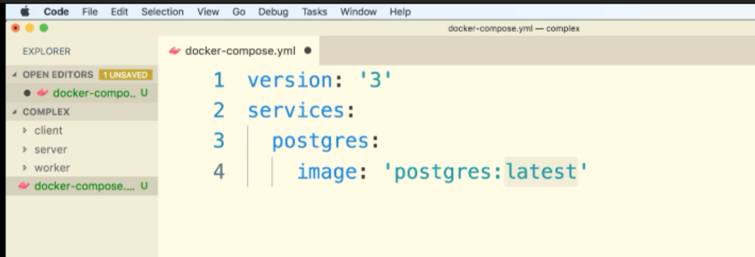

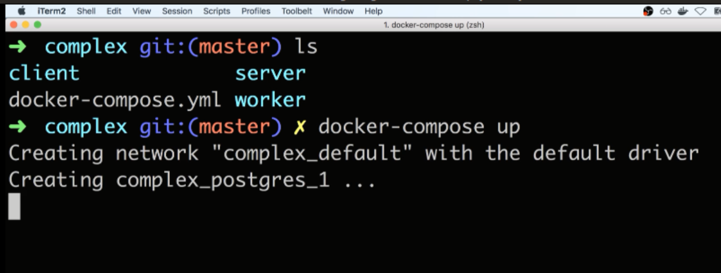

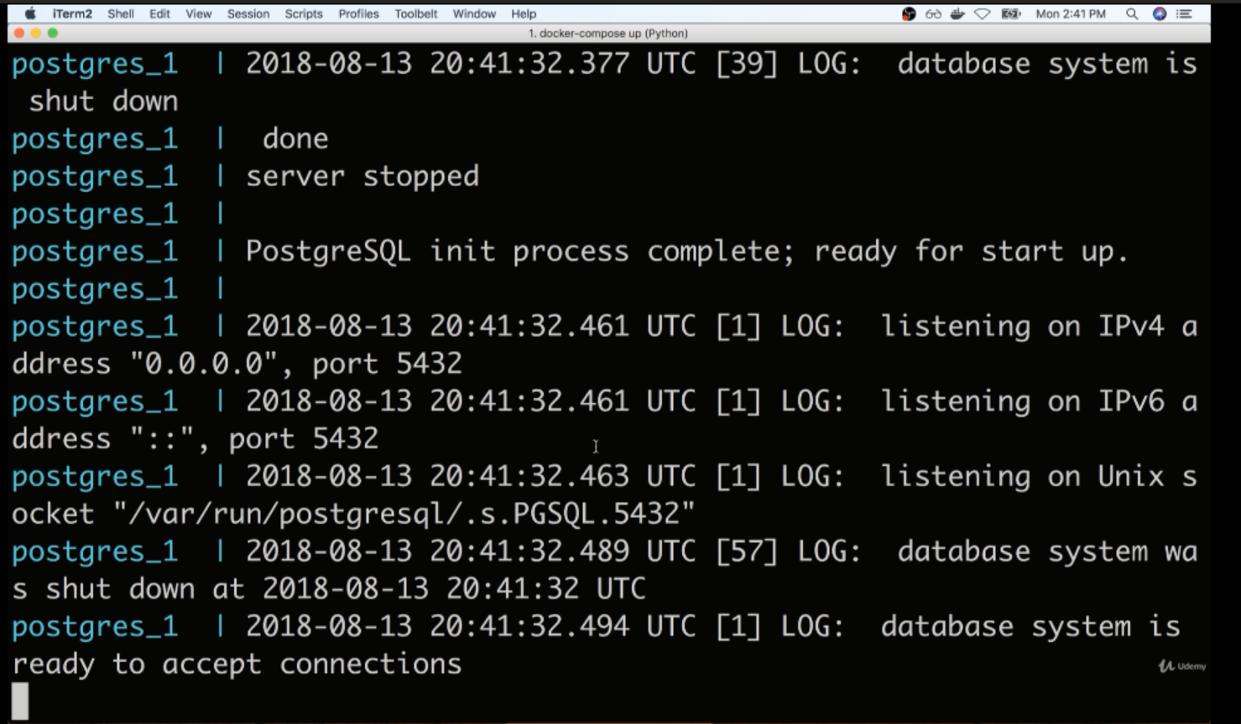

136:(Docker-Compose Config):

How to find the images:

Hub.docker.com/expore 🡪 there we can see images

Inside server we need to pass some build options to tell docker-compose how to build an image out of our source code.

Need to setup some volumes when anytime we change our source code those changes automatically get reflected inside of the container.

We eventually setup some environment variables because we want to customize how our container to behave when it starts up.

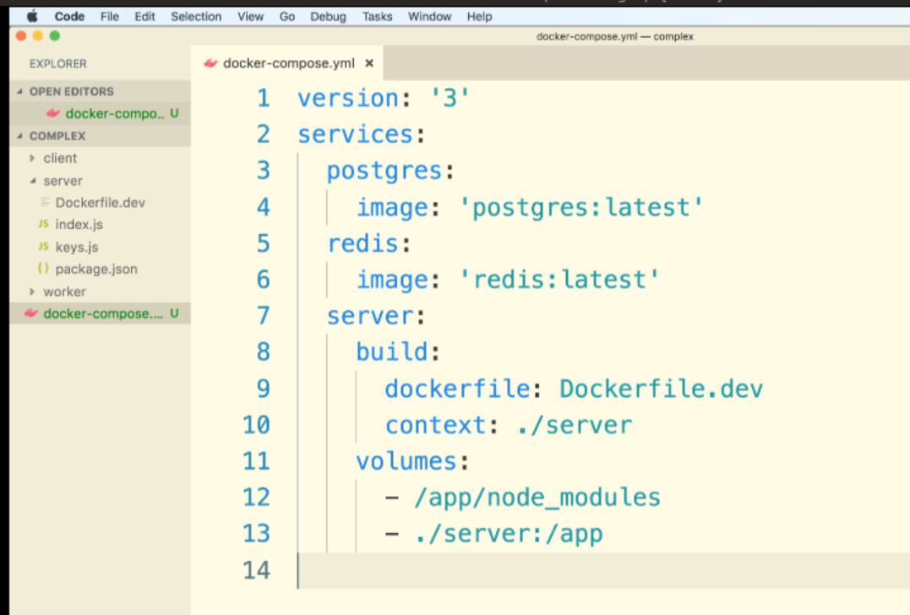

Context is the path to the Dockefile.dev

137:(Postgres Database Required Fixes and Updates):

***updated 6-12-2020***

Due to a recent update in the official Postgres image hosted on the DockerHub we need to make a change to our environment variables.

Add the following to your docker-compose.yml file in the **postgres** service:

postgres:  
 image: "postgres:latest"  
 environment:  
 - POSTGRES_PASSWORD=postgres_password

docker-compose down  && docker-compose up --build

Please note, all of these changes are reflected in the downloadable checkpoint zip files.

V—138:(Environment Variables in docker-compose):

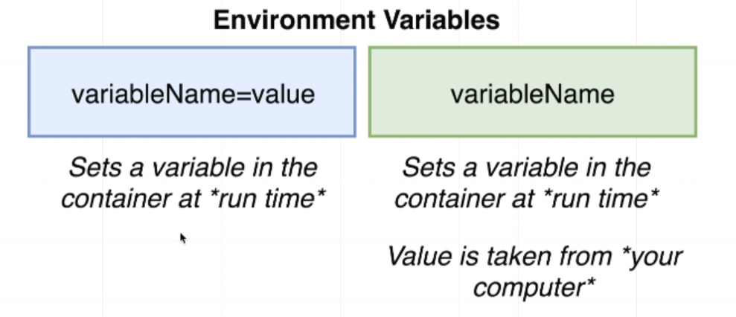

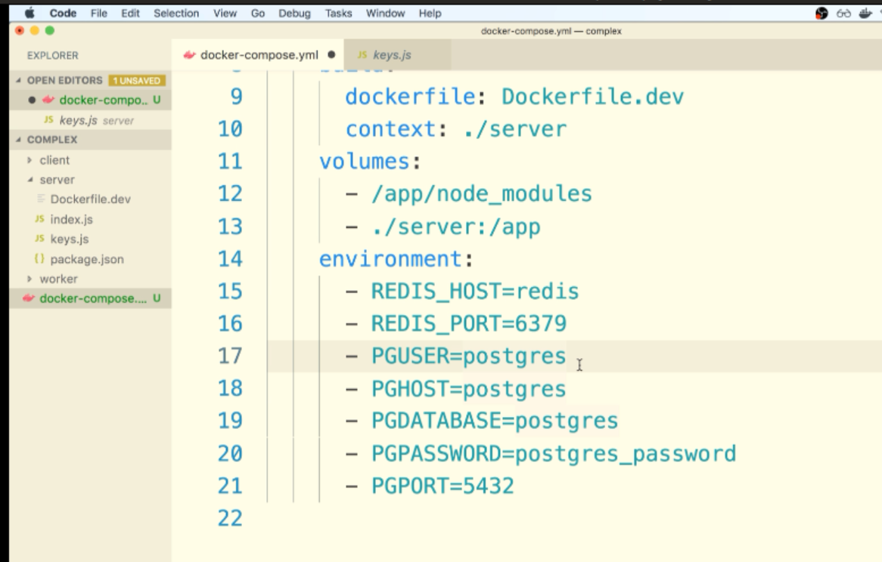

We have to look at the documentation to get some information about the default values.

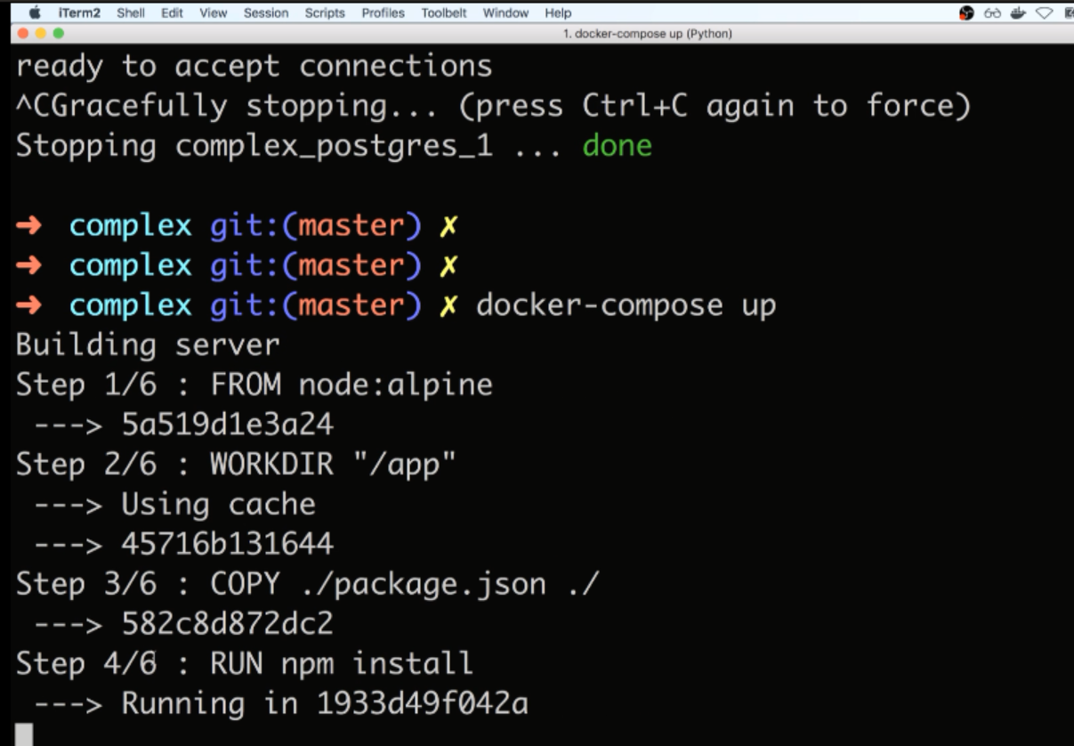

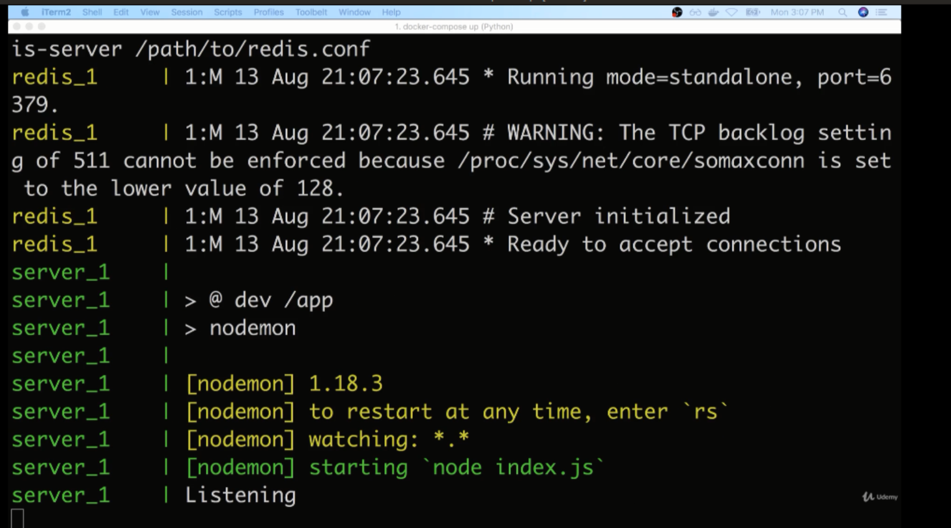

V—139:(Required Client Service Update and Worker Environment Variables):

In the next lecture, we will be adding a client and worker service. There are two required configuration updates that need to be made:

**1) When adding the "Client" service, be sure to include the stdin_open: true configuration:**

client:  
 stdin_open: true  
 build:  
 dockerfile: Dockerfile.dev  
 context: ./client  
 volumes:  
 - /app/node_modules  
 - ./client:/app

Otherwise, you will get a **"React App exited with Code 0"** error in your terminal when we attempt to start up the application.

**2) When adding the "Worker" service, include the Redis host and port as environment variables:**

worker:  
 build:  
 dockerfile: Dockerfile.dev  
 context: ./worker  
 volumes:  
 - /app/node_modules  
 - ./worker:/app  
 environment:  
 - REDIS_HOST=redis  
 - REDIS_PORT=6379

Otherwise, you will get a **"Calculated Nothing Yet"** error message.

V—140:(The Worker and Client Services):

Make sure that the node_modules directory inside the container does not get overridden by another other node_modues folder that we might have inside the client.

Setup a relationship between all the source code inside the client directory and the app folder inside of the container.

That means everything inside the client directory will be shared with the app folder inside the container,

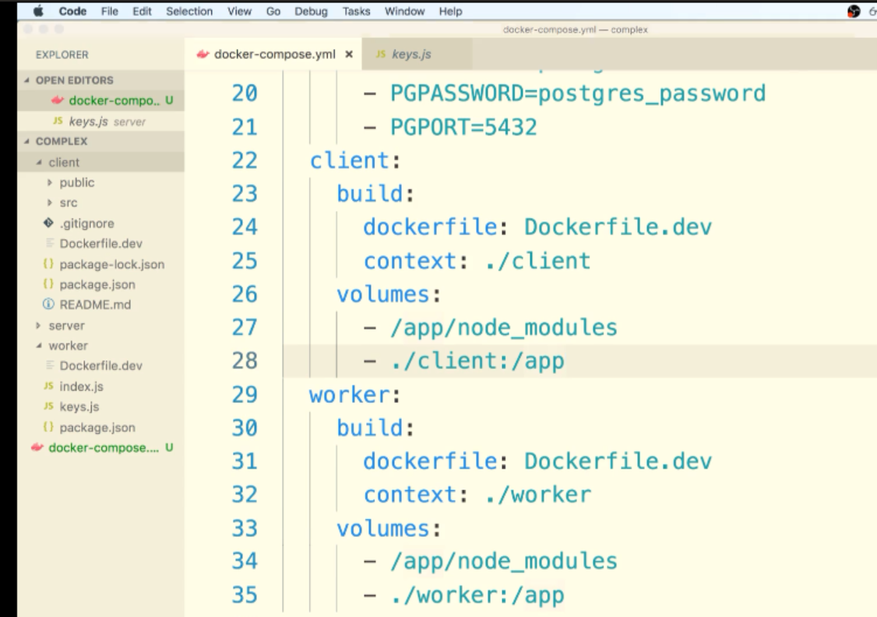

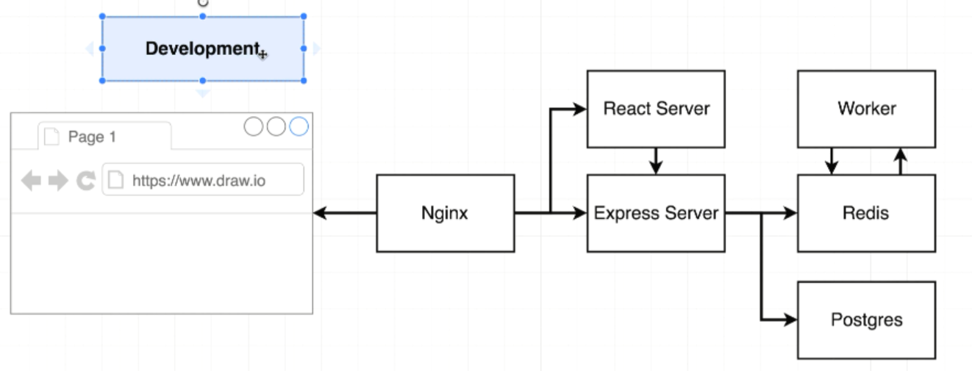

We have not yet setup any port mapping. So, there is no port mapping to expose server/client to the outside world.

Nginx routing requests from the browser to the react server or the express server.

V—141:(Nginx path routing):

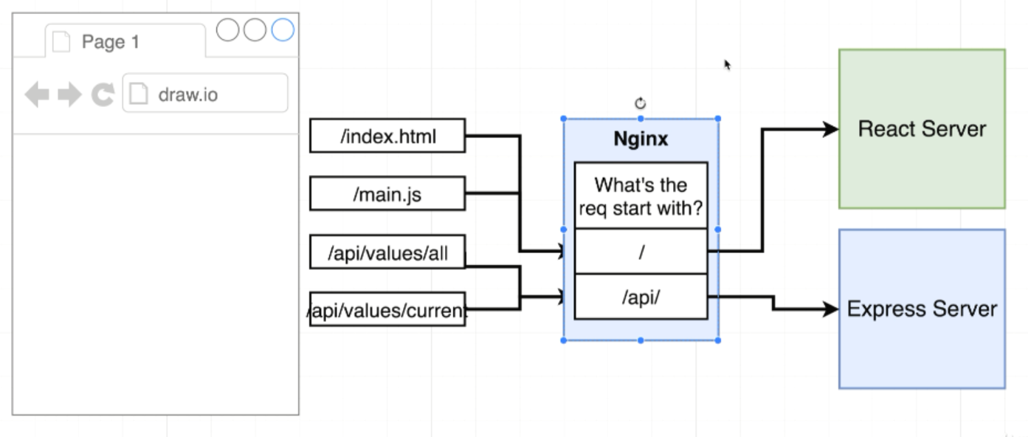

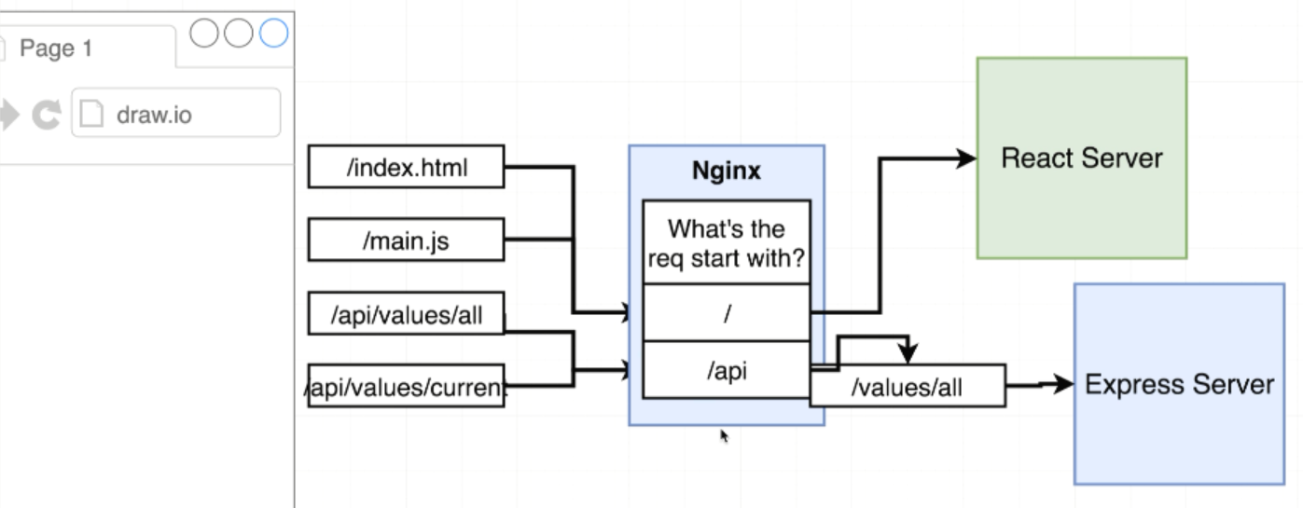

We can specify that routes with configurations with only change in the Nginx layer.

V—141:(Routing with Nginx):

default.conf gonna add configuration to implement that set of routing.

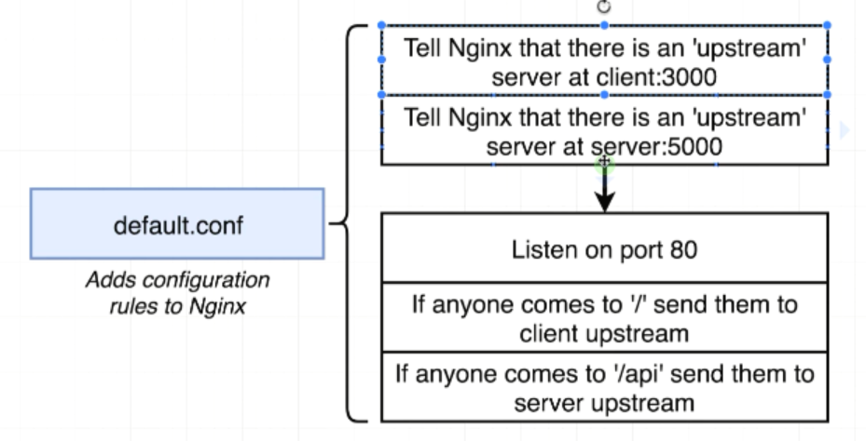

React server and Express Server are behind Nginx. We cannot access these servers unless you go through the Nginx server. So Nginx refers these as upstream servers.

We tell Nginx that it’s going to listen by default on port 80.

In-order to tell Nginx that the location of this upstream is client at 3000 we use the keyword server.

Change the server service name as api in docker-compose file.

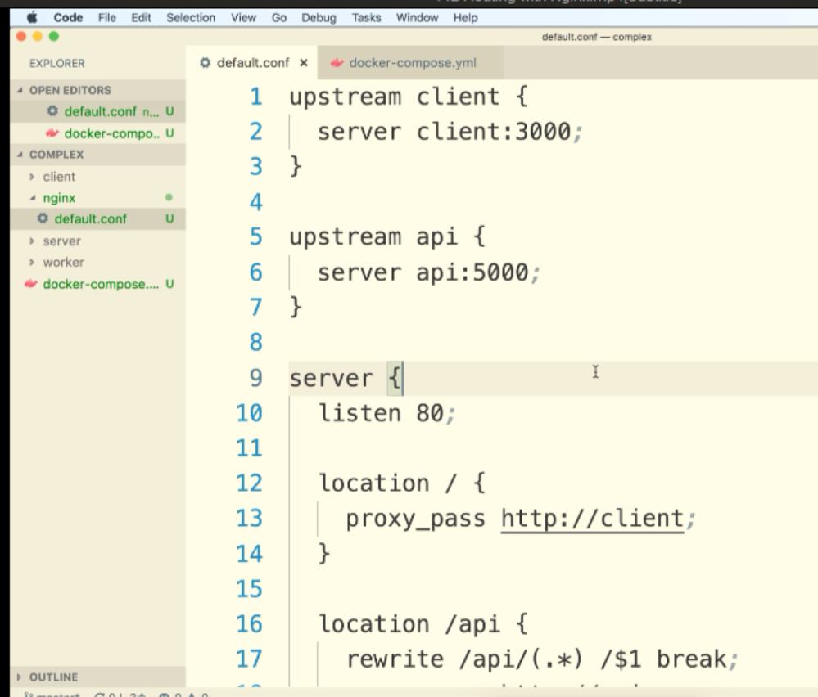

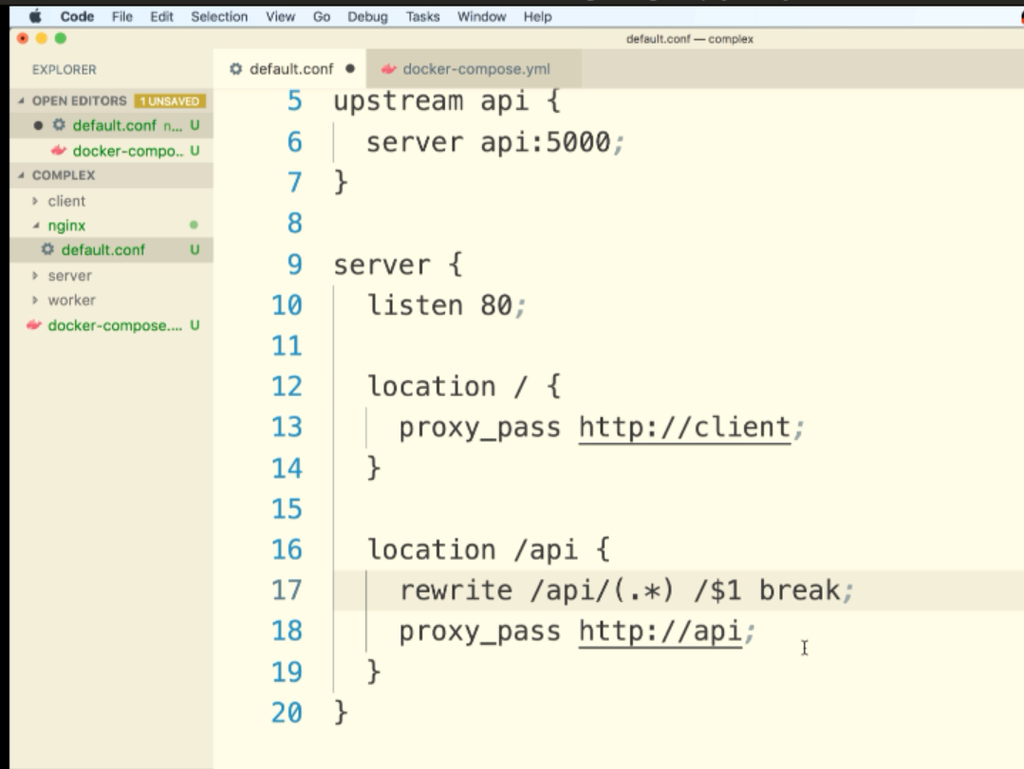

V—143:(Building Custom Ngnix Image):

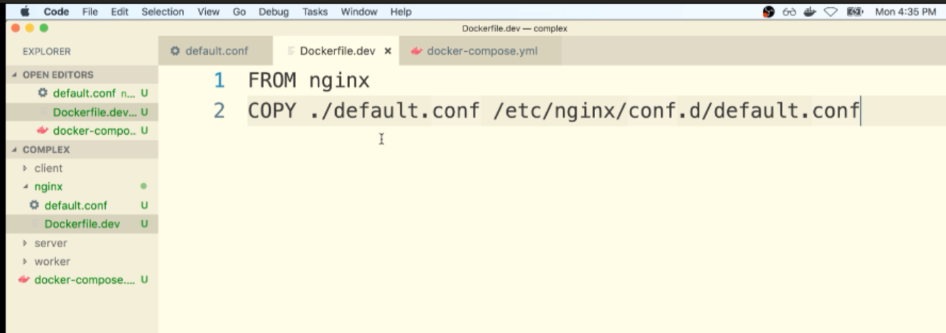

Adding Nginx to docker-compose.yml file:

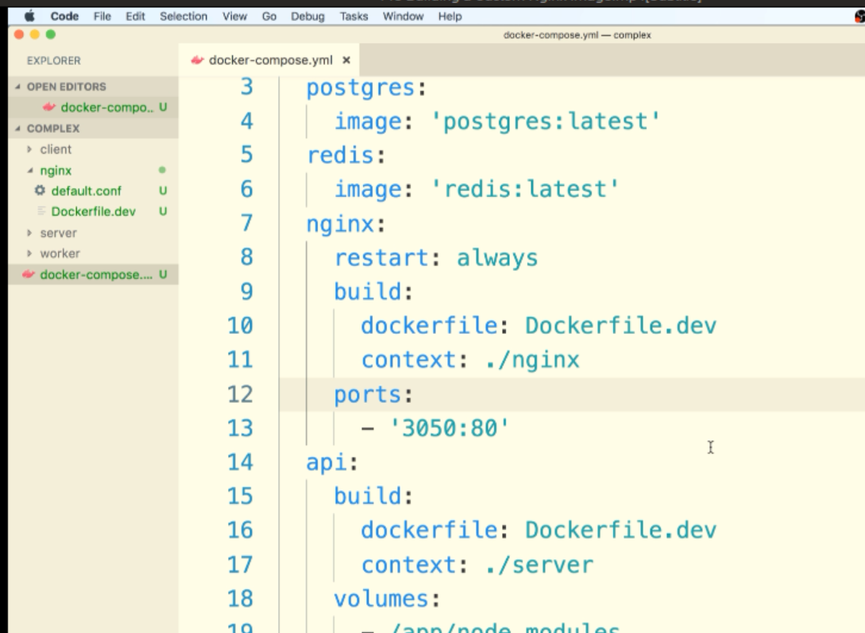

144:(Starting Up docker-compose):

Complex/docker-compose.yml:

version: '3'

services:

  postgres:

    image: 'postgres:latest'

    environment:

      - POSTGRES_PASSWORD=postgres_password

  redis:

    image: 'redis:latest'

  nginx:

    restart: always

    build:

      dockerfile: Dockerfile.dev

      context: ./nginx

    ports:

      - '3050:80'

  api:

    build:

      dockerfile: Dockerfile.dev

      context: ./server

    volumes:

      - /app/node_modules

      - ./server:/app

    environment:

      - REDIS_HOST=redis

      - REDIS_PORT=6379

      - PGUSER=postgres

      - PGHOST=postgres

      - PGDATABASE=postgres

      - PGPASSWORD=postgres_password

      - PGPORT=5432

  client:

    stdin_open: true

    build:

      dockerfile: Dockerfile.dev

      context: ./client

    volumes:

      - /app/node_modules

      - ./client:/app

  worker:

    build:

      dockerfile: Dockerfile.dev

      context: ./worker

    volumes:

      - /app/node_modules

      - ./worker:/app

    environment:

      - REDIS_HOST=redis

      - REDIS_PORT=6379

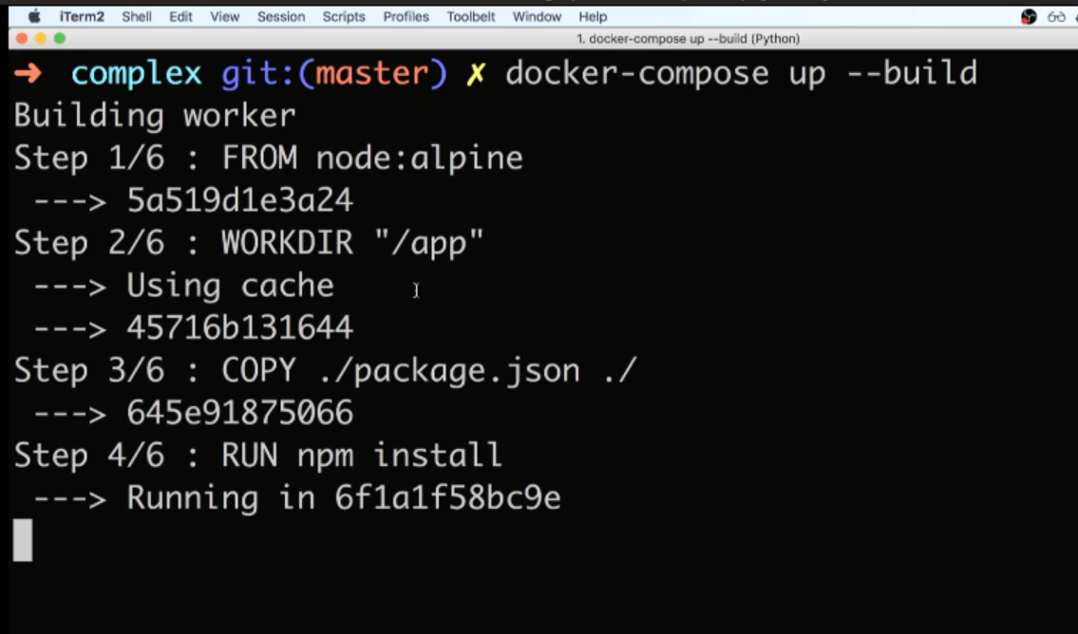

There might be a chance of crashing of the containers wihile starting it up for the first itme.

145:(Nginx connect() faied – connection refused while connecting to upstream):

A small number of students are hitting an edge case where the nginx upstream connection is failing after they run docker-compose up --build:

connect() failed (111: Connection refused) while connecting to upstream, client:[DOCKER INTERNAL IP], server:, request: "GET / HTTP/1.1", upstream: [NETWORK IP]

The solution they found was to add this to their nginx service in the docker-compose.yml file:

nginx:  
 depends_on:  
 - api  
 - client

complex/docker-compose.yml:

version: '3'

services:

  postgres:

    image: 'postgres:latest'

    environment:

      - POSTGRES_PASSWORD=postgres_password

  redis:

    image: 'redis:latest'

  nginx:

    depends_on:

      - api

      - client

    restart: always

    build:

      dockerfile: Dockerfile.dev

      context: ./nginx

    ports:

      - '3050:80'

  api:

    build:

      dockerfile: Dockerfile.dev

      context: ./server

    volumes:

      - /app/node_modules

      - ./server:/app

    environment:

      - REDIS_HOST=redis

      - REDIS_PORT=6379

      - PGUSER=postgres

      - PGHOST=postgres

      - PGDATABASE=postgres

      - PGPASSWORD=postgres_password

      - PGPORT=5432

  client:

    stdin_open: true

    build:

      dockerfile: Dockerfile.dev

      context: ./client

    volumes:

      - /app/node_modules

      - ./client:/app

  worker:

    build:

      dockerfile: Dockerfile.dev

      context: ./worker

    volumes:

      - /app/node_modules

      - ./worker:/app

    environment:

      - REDIS_HOST=redis

      - REDIS_PORT=6379

V—146:(Troubleshooting startup):

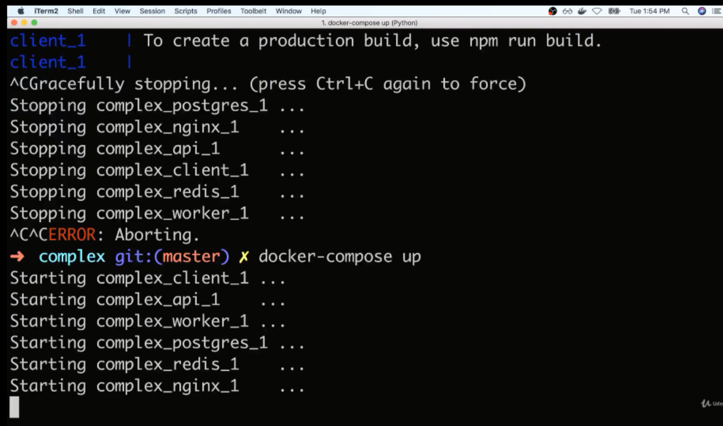

We got websocket error because anytime our react application boots up in the development mode it wants to keep a active connection to the development server and be notified of any time that some file changes.

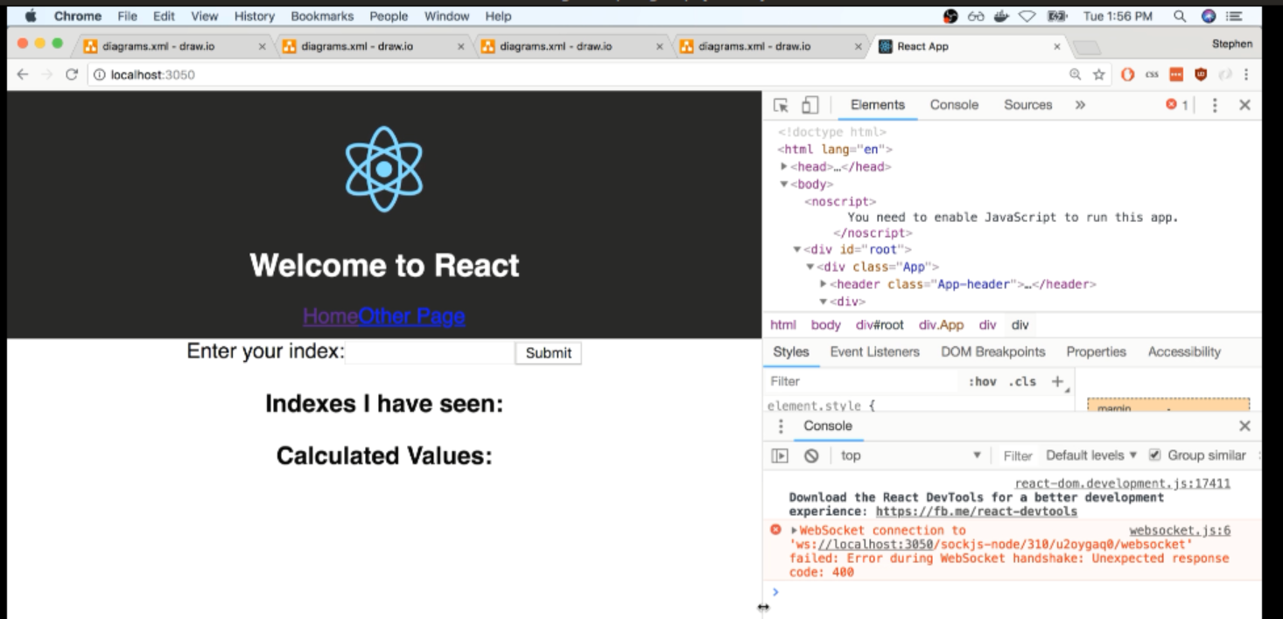

Before giving input and click on submit button:

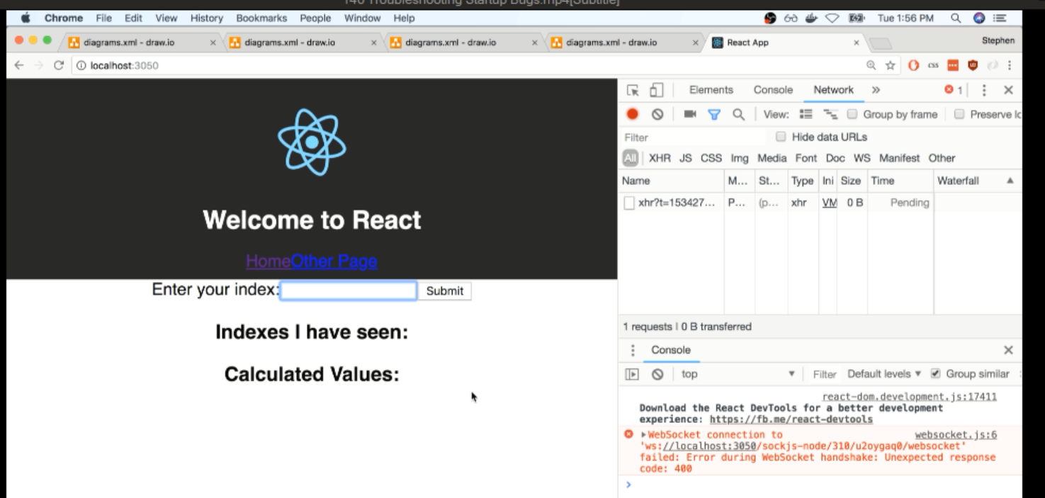

By not sending that websocket connection we actually going to very significiently impact the performance of our application which we can see by entering a value to the input as 5 and then click on submit it shows nothing like below:

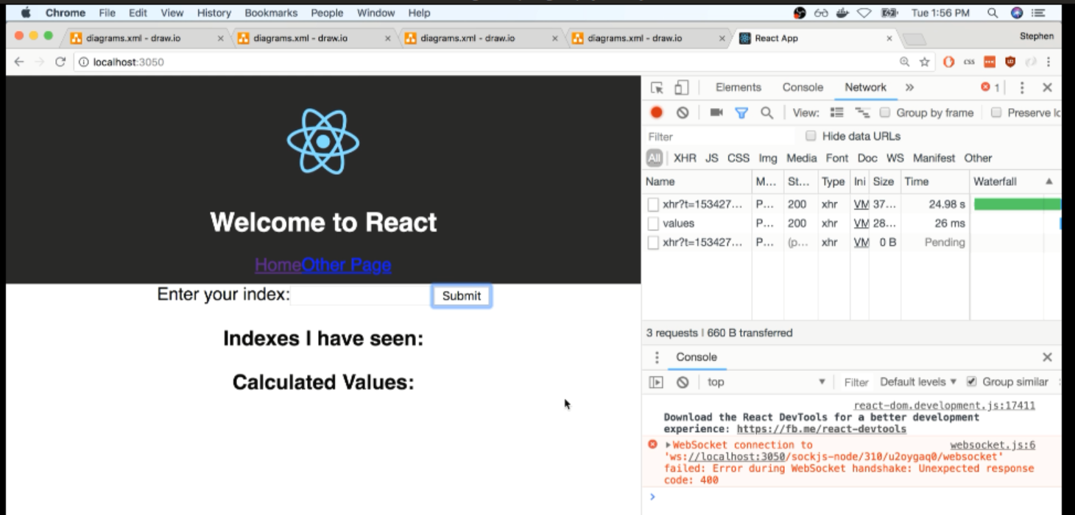

From above pic :: we might see values request taking large time.

When we refresh the page:

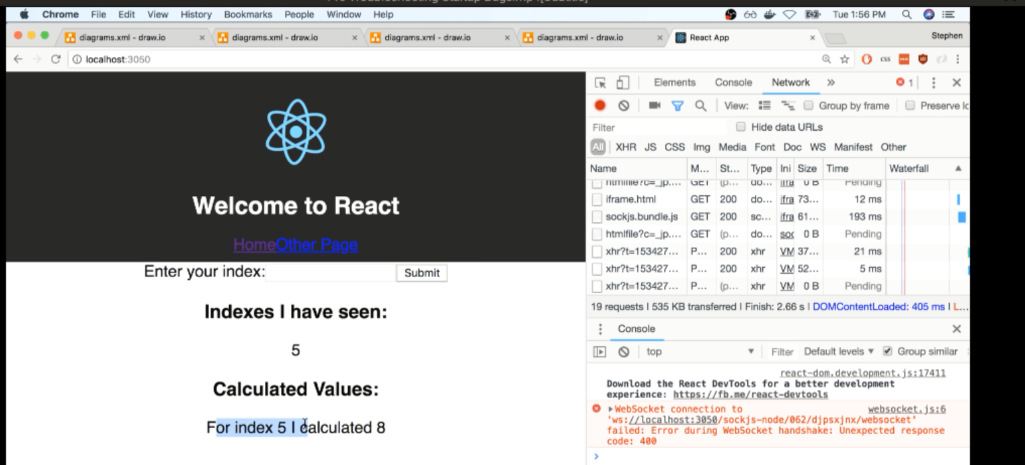

V—147:(Opening websocket connection):

Issue here is the browser running react app inside of it wants to get a active connection back to the development react server. So that it gets a notification anytime that our source code changes telling that the browser needs to automatically reload.

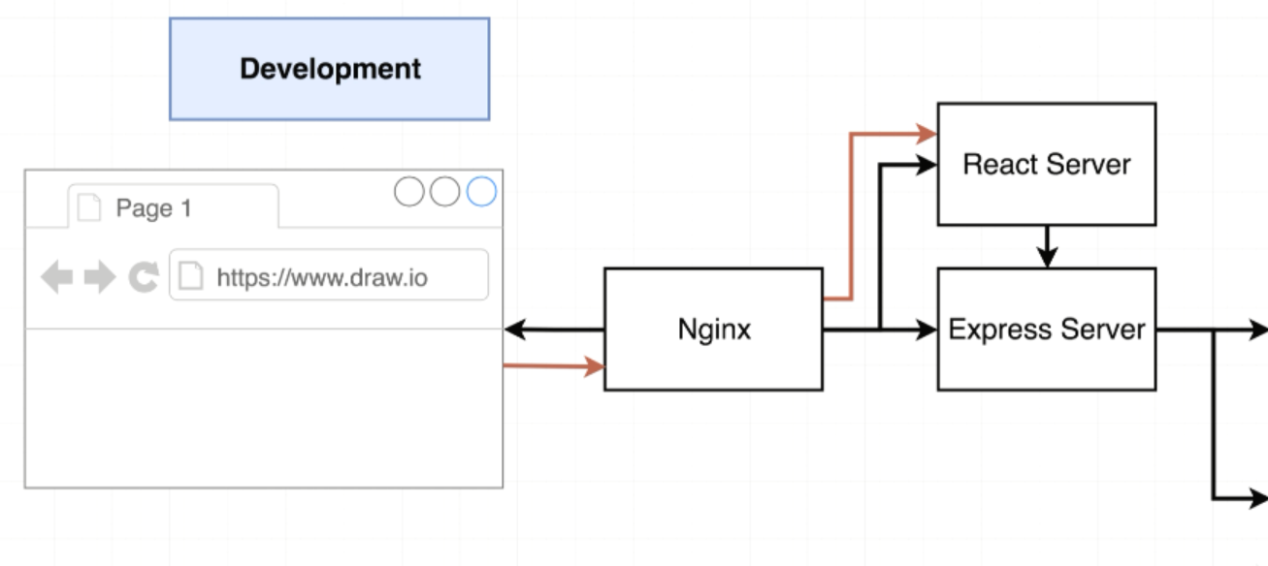

Problem: we have not set up our Nginx server to successfully allow through web socket connections

We are going to expose one routing layer or one route through the Nginx server that allow a web socket connection to be made with a running react process.

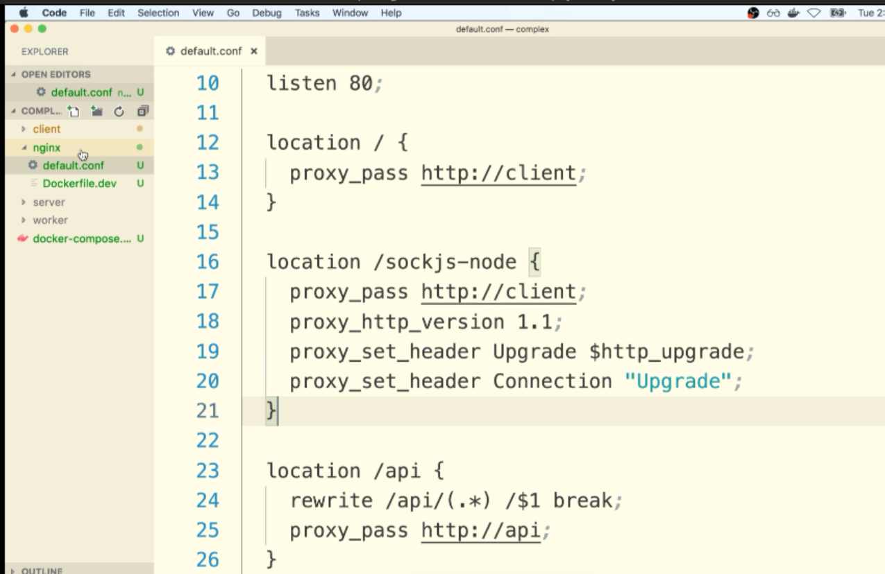

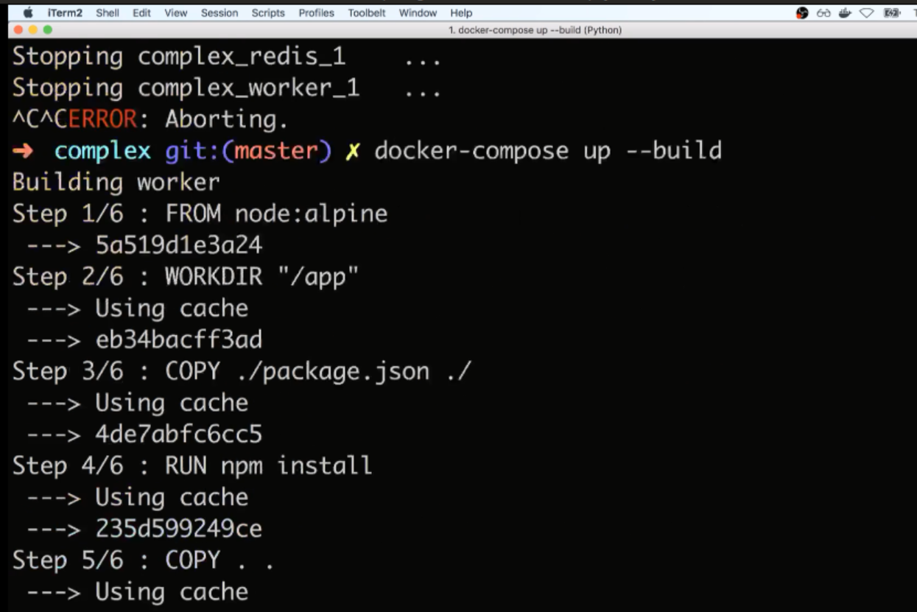

If you see any errors here, press cltr + c and use command docker-compose up

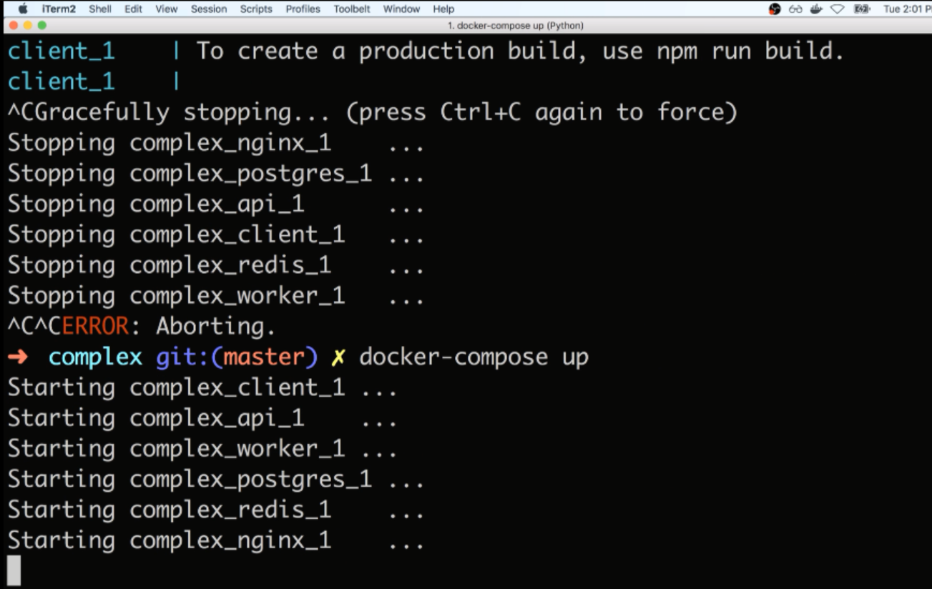

There some kind of dependency issues where sometimes the api is going to load up a little bit too quickly and that’s going to come online before redis and postgres are ready to receive connecitons

But when we eventually deploy this we are going to put a little fix that’s going to make sure that will not be an issue in a production environment.

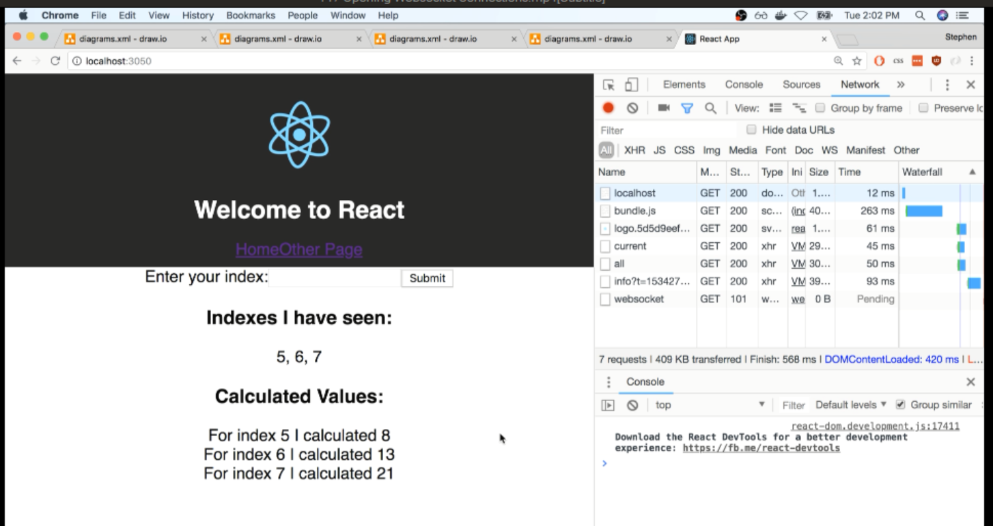

upstream client {

  server client:3000;

}

upstream api {

  server api:5000;

}

server {

  listen 80;

  location / {

    proxy_pass http://client;

  }

  location /sockjs-node {

    proxy_pass http://client;

    proxy_http_version 1.1;

    proxy_set_header Upgrade $http_upgrade;

    proxy_set_header Connection "Upgrade";

  }

  location /api {

    rewrite /api/(.*) /$1 break;

    proxy_pass http://api;

  }

}